Name:
Professor:
Course:
Date:
Challenges Faced by Working Women in UAE

ABSTRACT
To understand the problems faced by working women in the UAE, which is a global challenge, it is necessary to discuss the problem from developed economies. This paper examines the challenges faced by working women in the UAE, identifies the factors leading to these challenges, and provides strategies to address the issues. This research is supported by the survey conducted to ascertain women's opinions working in the public, private, and civil sectors in the UAE. The survey findings show that women face numerous challenges, including a struggle with work-life balance, harassment at the workplace, gender pay gap, managing between caring for their children, and accessing new career opportunities.
Based on the obtained results, certain indicators are vital, for example, equality, cohesion, provision of career opportunities, quality of life, and the ability to explore different opportunities. Identifying the correlation between the survey results and the future of working women in the UAE, it can be deduced that the present challenges can be addressed. Having a work-life balance, having equal pay as their male counterparts, and being given career opportunities to advance themselves and be treated with respect at the workplace.
Keywords: Work-life balance, gender pay gap, hardships, women empowerment, social duties

Contents
ABSTRACT 1
INTRODUCTION 3
The scenario of Working Women in the UAE 3
Research Questions 5
Aims and objectives 5
Objectives 5
Research Hypothesis 5
LITERATURE REVIEW 5
Challenges Faced by Working Women in the Middle East 6
Challenges faced by women in the UAE 7
Factors Promoting Challenges Faced by Working Emirati Women 11
Approaches Used by Organizations to Address Challenges Faced by Working Emirati Women 13
HYPOTHESIS 14
METHODOLOGY 14
Research Design 14
Ethical considerations 15
Research Instruments and collection procedure 16
Data analysis 16
Sample Technique 16
Intervention practices 16
STUDY RESULTS 17
DATA ANALYSIS AND DISCUSSION 20
Discussion and testing hypothesis 28
PLAN TO IMPLEMENT STRATEGIES DEVELOPED TO ADDRESS CHALLENGES FACED BY WORKING EMIRATI WOMEN 30
LIMITATIONS OF RESEARCH 31
CONCLUSION AND RECOMMENDATIONS 31
Works Cited 34
APPENDIX A 37
APPENDIX B 44

INTRODUCTION
This paper aims to conduct comprehensive research about the challenges, which working women in the United Arab Emirates (UAE) face. These problems are historical and continue to affect women's ability to perform optimally in their careers. The report will have two literature reviews on the challenges faced by women in the working class. These reviews will be followed analysis of the literature. The next section will be the methodology, which will cover choosing participants, sampling, and data collection. A results section and data analysis will be included. There will be a strategic plan to address the problem and a plan to implement the agenda in public discourse. A plan to evaluate the effectiveness of the created procedure will be developed. Limitations of the study will be discussed, and a conclusions section provided.

The scenario of Working Women in the UAE
Over the last ten years, different studies have been conducted to determine the various challenges facing working women in developed economies. Statistical information tracking working women indicates that most of them struggle with work-life balance, harassment at the workplace, gender pay gap, managing between caring for their children, and accessing new career opportunities (The Atlantic, 2019; IFC and CAWTAR, 2007). In developed economies, women play an important role in social, economic, political, and cultural development. However, their ability to perform optimally in these roles is inhibited by the existing economic policies, leading to occupational segregation (Verma et al., 2018).
The UAE is one of the most economically developed regions globally (Al Jenaibi, 2015). Despite the observed economic development, the percentage of women in the labor force is very small. This small percentage can be linked to the existing social perceptions and policies that inhibit women's participation in the labor force. According to a report published by Muhtaseb in the Arabian Business, UAE has a vast female talent pool that can be harnessed to work in complex and competitive workplaces. However, due to policies, cultural traditions, and the woman's position in society, working women continue to face pressure, affecting their motivation, performance, and productivity.
Traditionally, women have played a key role in keeping the Islamic religion in the region intact. Women have also been perceived as housewives, with their main role in nurturing children and taking care of children. Implementation of policies that support women's inclusion in the labor force and changing perceptions about women has led to an increase in the number of women in the workforce. Data collected by the World Bank shows an increasing trend in the number of Emirati women in the labor force in the last ten years. In 2020, there were 17.71% Emirati women in the labor force (Ryan & Patrick, 2020), compared to 11.14% in 2010, as shown in figure 1 below (Trading Economics, 2019).
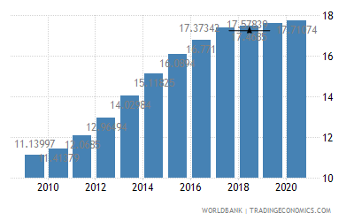
Fig 1: Percentage of the female labor force in the UAE from 2010 to 2020. (Source: The World Bank).
An increase in women's percentage in the labor force can be linked to the increasing number of women enrolling in schools (World Inequality Report 2018). Promoting education among women and women empowerment programs have enabled women to advance themselves, personally and professionally. Educating women has also improved their literacy levels, allowing them to work in political and economic scenes. Even though women's positions have been elevated in the community, they still face numerous challenges (Ryan & Patrick, 2020: Verma et al., 2018).). Thus, it is necessary to develop strategies that can minimize the severity of women's problems in the workplace.

Research Questions
- How women maintain a balance between their personal and professional lives?'
- How their families and the relationships between husbands and children are affected?'

Aims and objectives
This report aims to examine the challenges that women in the labor force in the UAE face. Also, the report will offer strategies that can be used to alleviate the severity of these challenges.

Objectives
- Examine the challenge faced by working women in the UAE
- Explore factors leading to identified challenges in the UAE
- Identify solutions to the identified issues

Research Hypothesis
The study seeks to test the following research hypothesis
Hypotheses of H1: there is a relationship between challenges and women working in the UAE
Hypothesis H2: more challenges means more discrimination against women who need support

LITERATURE REVIEW
This chapter will include two literature reviews. The first literature review will address challenges faced by working women in the Middle East, UAE, and the factors which promote the problems. The second literature review will discuss how different institutions have helped to address the challenges. The chapter will also discuss approaches that can be used to implement and sustain change in the region's labor force.

Challenges Faced by Working Women in the Middle East
Women working in the Middle East today experience a broad range of challenges, both at the workplace and family. The workplace challenges include unequal pay, lack of leadership opportunities, gender bias, harassment, and short maternity leave. Working women at the family face challenges like time balance, responsibilities of a mother, social duties, and limited time with the family because of business trips and meetings. These two categories of challenges are consistent with the roles women play in a family's social and economic levels. Women get an education and enter the labor market to advance their families' economic status, personal advancement, and achieve higher social status. The ability of women to achieve a higher financial status in the family gives them economic freedom. However, the achievement of economic independence comes with a couple of challenges. Arab society is structured under masculine structures (Sanhouri 45). In this context, women in the Middle East are feminized. Women are seen as fragile. Their fragility is associated with the issue of insecurity. Different researches over the years in this region show an increase in the rate of female abduction (Wanninayake 57). As a result, different policies have been implemented to limit their movement. Limiting women's movement affects their ability to engage in the labor force optimally. These policies have negative implications on women because work demand at least eight working hours.
Another challenge is the high poverty rate among women compared to men. The 2018 World Inequality report shows that Arab societies have developed discriminatory practices over the years. These practices are believed to begin at birth; for instance, women are discriminated against from birth, allowing men to advance themselves further. The gap between men and women from birth inhibits their abilities to succeed in academics and life in general. Women are denied the ability to access the necessary resources to advance education and the labor market. Lack of skills in life, which is linked to the gender gap, exposes women to poverty. Also, women who get an education are exposed to the challenges of getting employed. Due to feminization, women are perceived as weak and unable to reach employers' expectations. The majority of employers in the Middle East prefer to employ men, limiting women from potential employment opportunities.

Challenges faced by women in the UAE
Women in the UAE are among the most respected people globally because of the advocacy of social justice in its constitution. Since the start of the 21st Century, women have played a critical role in social, economic, cultural, and political development in the region. In the UAE, women have been allowed to advance themselves in the labor market. Women are allowed to advance themselves alongside men, helping them to gain economic independence.
Although social perceptions about women have rapidly changed in the last two decades, women working in the Middle East continue to face social pressures and overwhelming barriers to advance themselves. According to Verma and Mulani, working women face a challenge in the acquisition of leadership positions in workplaces. Limited leadership opportunities are associated with the fact that most leadership positions in the UAE are held by men (Muhtaseb). With leadership positions being dominated by men, women are left with limited opportunities to be included. Male dominance in leadership positions is associated with the problem of gender biases. As previously stated, Emirati women begin to face biases in the early stages of life, making it a challenge for society to accept women working in the same spaces as men. In almost all major commercial sectors, male dominance in leadership and other positions is visible. As a result, the community develops with an unequal distribution of resources between men and women.
Another challenge faced by working Emirati women is work-life balance. Work-life balance is one of the major challenges affecting employees across the world. It is a challenge associated with the inability to coordinate between work roles and family life. Organizations that do not support their employees' work-life balance can incur direct and indirect costs due to reduced employee productivity, increased employee turnover, high-stress levels, and long overtime hours (Jabeen et al.). Emirati women can now advance themselves because of the new policies implemented to give women equal rights and opportunities as their male counterparts. Today, Emirati women account for 45% of the active employees in the UAE. More than 40,700 Emirati women are currently in the labor force, which significantly increases in the last two decades. The quality, proportionality, and components of the UAE's work environment have promoted the position of women. The public sector accounts for 40% of the total female workers, with only 5% working in the private sector (MENA-FN). The higher number of female employees in the public sector is associated with higher benefits, job security, and employee work-life balance promotion. Although the public sector plays a critical role in promoting women's economic independence, the sector has been experiencing higher turnover in recent generations (Jabeen et al.). A 2015 UAE Federal Government report identified that women accounted for the highest employee turnover, at 64% (Federal Authority for Government Human Resources).
The achievement of work-life balance for women working in the UAE is critical because it is a determining factor of the region's continued progress in life's economic and social aspects. Despite organizations' role in public and private sectors to promote work-life balance, Emirati women still face challenges at work because of inconsistency between their interests and organizational demands. As a result, women tend to change jobs in search of satisfaction quickly. High employee turnover among women can be associated with a lack of job satisfaction, misalignment between work roles and personal life, and distressing operations at the workplace. Work-life balance among Emirati women is a major challenge because women's careers and professional lives are perceived as a secondary role after taking care of the family's needs. In trying to balance between work and personal life, women can often get stressed, which, in turn, affects their ability to work optimally and even fulfill family expectations. Emirati women in the labor force also face the challenge of mental and physical harassment at the workplace and even in their homes.
Despite the significant changes, which have taken place in the UAE in terms of improving women's lives, health and promote economic independence, they are still perceived and "second hand" citizens. In this context, women are controlled by men because they lack the opportunity to make decisions that affect their lives and family. Because of male leadership dominance in the workplace and at home, female employees are left vulnerable to harassment and discrimination. Begum states that women are required to respect their husbands' decisions and their male counterparts, contrary to which they are considered to have broken the law. The inclusion of discriminatory laws in the constitution limits the ability to work women to make independent decisions. Gender-based violence in the UAE is also associated with the fact their laws do not address violence against women or provide guidelines to the courts and the entire justice system. The law fails to outlines the roles and responsibilities of government agencies, the police, courts, and non-profit agencies to protect women's rights. Therefore, harassment at workplaces and in their homes can be taken for granted, leaving the women vulnerable and unable to perform optimally. Women are also excluded from labor law protections, which exposes them to higher probabilities of abuse, harassment, and exploitation (Begum). Reports by the Human Rights Watch have shown that some local and migrant women working in the UAE can work for up to twenty-one hours a day. Also, instances of sexual and physical abuse have been reported. However, reporting these cases has not changed the situation, considering there are no provisions in the constitution on how the justice system can address the issues.
The codes developed over the years in the Islamic culture require women to seek their husbands' permission before they engage in any decision or duty. Working Emirati women have to get permission from their husbands to get employment or even participate in work meetings. Women working in leadership positions are under high pressure, particularly when attending work meetings and training programs. They have to seek their husbands' consent. Otherwise, it is considered a violation of Islamic law. Before engaging in these meetings and training programs, they also have to ensure that their children are well taken care of. Also, they have to ensure that everyone in the family is on board with the plan. Subjecting women to these tough working conditions and balancing them with family expectations exposes them to high probabilities of developing stress and other mental health issues.
Because of women's insecurity and vulnerability in the UAE, many families do not support women engaging in the labor market. Cultural traditions are framed so that women's primary role is to take care of domestic chores while men go to work and promote their families' financial status. Failing to support working women and limiting their work time affects their work performances, prompting them to miss important organizational promotions (Al Jenaibi ).
In terms of payment, women are paid lower wages compared to their male counterparts. Although women have shown their increased competence and performance compared to men, they are still paid at lower rates, which affects their motivation to work and perform better. In a 2020 report by the World Economic Forum (WEF), it was identified that the Middle Eastern region was in the lower 25th percentile in terms of gender gap pay (Ryan). The UAE was ranked 120th out of 153 countries in the Global Gender Gap Index. These statistics show that there is a major gap between men and women in terms of wages. The same report estimated that if the same policies implemented to address the gender gap will be used, it could take more than a Century and a half to address the gap. Thus, studies portray that much needs to be done to achieve equality despite policies addressing women's labor market position.
Another challenge that working Emirati women face is the inability to address their children and husbands' needs. Working women spend most of their time in their work, attending meetings and other training programs. These work activities prompt them to miss out on important activities through their children's development and learning process. Children who grow without their mothers' influence in their education, health, and physical development can lack important skills like how to socialize, how to multitask, and how to solve real-life problems. Mothers also play a critical role in creating social bonds between their children, husbands, and the entire community. These ties are vital for the future success of the children. However, due to work roles, women poorly perform their social duties, which can affect the family's wellbeing.

Factors Promoting Challenges Faced by Working Emirati Women
Numerous challenges have been associated with the increased severity of challenges facing working Emirati women. One of the factors is the existing cultural and social restrictions that the constitution has among women. These restrictions increase the severity of the discussed challenges because they are denied an opportunity to get an education and the necessary tools to succeed in the highly competitive and dynamic labor market. The second factor is the established masculine culture, which inhibits women's movement and the achievement of economic independence. Arabic traditions, which are the basis of the country's constitution, restrict women's ability to engage in different activities. Besides, families, which are led by men, restrict women from seeking employment. These restrictions are linked to the assumption that women's primary role is to be a housewife. The third factor is the constitution's failure to have provisions addressing women's security and equality in the family setting. In this context, men are the key decisionmakers, with women required to follow the man's decisions. Also, in the case of violation of a husband's rules, she can be punished according to the law. The constitution has provisions allowing men to punish their wives as long as there are no visible bruises. Violence against women decreases their ability to enter or succeed in the labor market. Although the access and use of technology among Emirati women has increased significantly, there is still a huge gap compared to the percentage of men accessing technology. These differences hinder the ability of women to contribute to the business world. Figure 2 below shows the number of women engaging in business operations using ICT.
Lack of business training and mentoring is also linked with the increased severity of challenges facing working women in the Emirates. Women are hardly allowed to showcase their talents and capabilities. Employers seek to employ male employees who they perceive to be better performers. Failure to give women an opportunity and train them puts them at a disadvantage compared to their male counterparts (International Finance Corporation (IFC) and Center for Arab Women for Training and Research (CAWTAR)). Besides, most of the leadership positions in the public and private sectors are dominated by men. It becomes a challenge for qualified or rather competent women to get trained and mentored for different roles. Due to lack of training and mentoring, thousands of qualified and talented women waste their skills and give up on employment.
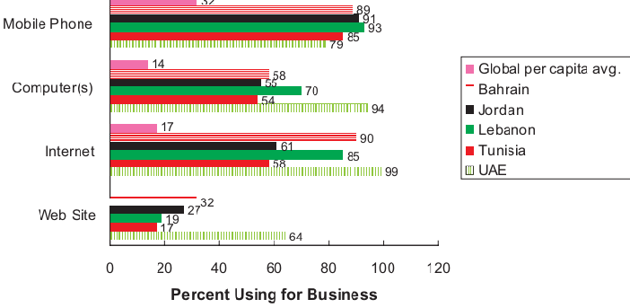
Fig 2: Percentage of women engaging in business through ICT (Source: MENA, 2010).

Approaches Used by Organizations to Address Challenges Faced by Working Emirati Women
Today, public, private, and non-profit organizations play a key role in empowering women to become a staple of corporate activity in the country. These organizations have played an important role because women are considered an underutilized resource in the labor market. In a report by Wesely and Dublon. Because women have contributed to the growth of UAE's GDP by approximately 12%, different organizations have taken an interest in empowering this population and tap the underutilized talents. An organization like the Center of Arab Women for Training and Research (CAWTAR) plays a critical role in promoting Arab women's role in the labor market. This organization has five programs, which are designed to promote the position of women. CAWTAR researches the development of Arab women and publishes them to create awareness on how these developments have gradually evolved. The organization empowers women to be part of the country's labor force by developing training programs consistent with their interests and academic attainments. Another approach used by organizations in the UAE to alleviate the challenges women face is establishing networks and partnerships between educated women and potential employers and amongst themselves. These partnerships are essential and can help reach talented and educated women in marginalized areas and the underprivileged. Organizations have also maximized the use of technologies to promote communication, integration, and learning processes. The presence of several social media platforms enables women to showcase their capabilities to potential employers. Through these platforms, they can access more employment opportunities and obtain relevant information in real-time. The introduction of digital technologies in business is vital because it helps women engage in online businesses.

HYPOTHESIS
This study seeks to test the following hypothesis.
H1: There are various challenges while working women maintain the balance between their professional and personal lives.
The variables of the study are outlined below.
Independent variable – Working women
Dependent variable – husband and children

METHODOLOGY

Research Design
The inclusion of a research methodology is important because it offers insights into how data was gathered and the analysis processes involved. According to Snyder & Hannah (2019), there are different research methods, including experiments, interviews, questionnaires, case studies, surveys, and observational trials. The most commonly used methods are qualitative and quantitative research methods. Qualitative research focuses on understanding the reasons, perspectives, and motivations towards a certain activity. This method of research helps researchers develop hypotheses for research. Additionally, it is used to determine trends in processes essential for gaining a deeper understanding of a research problem. Qualitative research methods include observational studies, interviews, and group discussions (Snyder & Hannah, 2019).
On the other hand, quantitative research methods focus on quantifying a problem by providing quantified data that can be translated into meaningful statistics. As compared to qualitative research, quantitative research methods are more structured. They include surveys, systematic observations, interviews, online polls, and questionnaires (Zangirolami et al., 2018). Therefore, in conducting research, it is essential to understand the appropriate research method that can answer the research question. According to Zangirolami et al. (2018), understanding a research method is essential for researchers because it helps determine the results and conclusions. Also, they can be used to help in the process of developing research recommendations.
Conducting this study is important because it will improve the existing knowledge about working Emirati women's challenges. Also, the research will help develop strategies that can be used to alleviate the severity of these challenges among women. For this study, the most appropriate research method is a quantitative method. A survey will be conducted to gather the findings of the research. Different factors will be put into consideration during the study.

Ethical considerations
The first consideration to make is to consider the rights of the participants. The research will put into consideration five ethical principles to protect the wellbeing of participants. The first principle is to ensure that participants are not exposed to any harm, obtain informed consent, protect the participants' privacy, avoid immoral practices, and provide the participants with the right to withdraw from research.

Research Instruments and collection procedure
Another thing that will be considered in the research is the collection of data. Different data variables will be collected and used to compare the existing knowledge and that from the findings to determine the best approaches to address challenges faced by working women. A survey will be conducted using questionnaires. Participants will be required to answer 30 questions. These questionnaires will be sent by mail to all participants. Participants will be given one week to address the questions and send the answered sheet via mail. This process will ensure that data is not tampered with and that the participants' information is correctly used.

Data analysis
Different techniques will be used to analyze the data to determine its meaning. The analysis of the results using SPSS software will also help the researcher draw informed conclusions ( Frey, 2017).

Sample Technique
The population used in the research will be carefully selected to ensure that the research objectives are met. A randomized sampling technique will be employed to ensure that the research has an equal representation of the study population. Additionally, a random sampling technique will ensure that all study groups are included, thus promoting reliable results. An adequate sample size (two-hundred working Emirati men and women) will be used in the research to ensure that the results obtained are conclusive. The sample will include eighty men and 120 women. Besides, an adequate number of participants is important because it will ensure that the results are generalized.

Intervention practices
Intervention practices will also be put in place to ensure that any unexpected changes during the research are addressed. Intervention practices are also important because they ensure that the research does not deviate from the expected outcomes with a big margin. The procedure of data collection will also be closely monitored to ensure that there is no bias. Biasness will also be avoided by having expert opinions from other experienced clinicians. Firsthand information from the participants will be obtained by the use of questions asked by email.

STUDY RESULTS
The results of the survey are presented in the tables and charts below.
Table 1: Showing the age of participants, gender, and the number of working women.
Age (years) | No. of participants | Gender |  | Employment status of the Females
 |  | Male | Female
0 – 15 | 2 |  | 2 | 0
16 – 30 | 87 | 27 | 60 | 56
31 – 45 | 89 | 48 | 41 | 42
46+ | 22 | 5 | 7 | 9

Table 2: Education attainment of the participants
Level of education | No. of participants
High school | 46
Bachelor's degree | 146
Master's degree | 7
Ph. D. | 1

Chart 1: Level of education
Table 3: Level of household income
Household income | No. of participants
Less than $25000 | 48
$25000 - $50000 | 100
$50000 - $100000 | 30
$100000 - $200000 | 20
Above $200000 | 2

Chart 2: Level of household income
Table 4: Likert scale
Likert question | Strongly disagree | disagree | neither agree nor disagree | agree | strongly agree |  | Mean | SD
I | 2 | 10 | 20 | 56 | 112 |  | 4.33 | 0.919
II | 0 | 0 | 5 | 65 | 130 |  | 4.63 | 0.535
III | 20 | 14 | 28 | 31 | 107 |  | 3.96 | 1.365
IV | 5 | 33 | 11 | 57 | 94 |  | 4.01 | 1.190
V | 78 | 69 | 12 | 19 | 22 |  | 2.19 | 1.339
VI | 67 | 70 | 19 | 31 | 13 |  | 2.27 | 1.254
VII | 13 | 23 | 60 | 55 | 49 |  | 3.52 | 1.169
VIII | 4 | 10 | 11 | 44 | 131 |  | 4.44 | 0.949
IX | 2 | 17 | 8 | 71 | 102 |  | 4.27 | 0.955
X | 45 | 50 | 23 | 63 | 19 |  | 2.81 | 1.348
XI | 19 | 41 | 20 | 54 | 66 |  | 3.54 | 1.378
XII | 8 | 12 | 12 | 76 | 92 |  | 4.16 | 1.049
XIII | 104 | 56 | 13 | 17 | 10 |  | 1.87 | 1.168
XIV | 99 | 67 | 4 | 21 | 9 |  | 1.87 | 1.153
XV | 4 | 2 | 20 | 78 | 96 |  | 4.30 | 0.845

DATA ANALYSIS AND DISCUSSION
This study showed that the hypotheses are true and that was clear in the literature review and even in the survey I do there is relationship between maintain the balance and professional and personal life for working women. That was clear when the women answered in surveys. The results in Table 1 show the number of women of different ages in the labor force. From the obtained responses, 107 respondents were found to be working. Fifty-six workers were between ages 15 – 30 years. Forty-two of the employees were between ages 30 and 45. Nine workers were identified to be over forty-five years of age. Some of the responses provided in table 1 were provided by male participants, who responded to their wives' employment status.
Findings in this table indicate that the number of female workers in the UAE has increased over the years. Young female employees between ages 15 – 30 represented most of the employees, accounting for 52.33% of the employed population. Women between ages 30 – 45 accounted for 39.2% of the employed participants, and those aged above 45 years accounted for 8.4%. These findings indicate that more young female recruits are being included in the labor force.
I find that working women face various challenges affecting her ability. To balance between personal and professional life she can’t mange between the work and family I can nothing the Emarti challenge in this point. Social cultural -man control-manging time _soical duites working women in the Emirates that hinder the prosperity of women and their responsibilities as a mother who takes care of the children. Results in Table 2 indicate the level of educational attainment for the participants. The education level with the largest population was a Bachelor's degree, with 146 respondents, followed by high school with 46 respondents, Master's degree with seven respondents, and Ph. D. with one respondent. This table shows a significant increase in educational attainment among women. Increased education attainment can be linked to the increased number of employed Emirati women, as identified in table 1. The results of table 2 are also represented in chart 1, as shown.
Table 3 provides findings on annual income in $. The majority of the females (50%) were paid between $25000 - $50000 per year. 24% of the participants responded that they earned less than $25000 per year. 15% of the women earned between $50000 - $100000 per year, 10% of the women earned between $100000 - $200000, and 1% earned above $200000 per year as shown in chart 2. These findings indicate that there is still a wide gender wage gap between working men and women in the UAE. The most paying careers most preferably were designated for men, cramming women in the lower-paying jobs. Despite that approximately 40% of Emirati women work in the public sector, which offers better job security, they are still paid less for men's same job. 1% of females earning above $200000 per year indicates that very few women are in executive and leadership positions.
The findings in table 4 represent responses of participants regarding different challenges facing working women in the UAE. In the question of cultural values' role on women's professional development, 122 respondents strongly agreed that cultural values hindered women from developing professionally. Fifty-six participants agreed that cultural values contributed to decreased professional development among Emirati women. Twenty of the participants were neutral regarding the question, ten disagreed, and two strongly disagreed. In this context, cultural values were identified as a major challenge affecting working women in the country.
In the second question regarding work-life balance, 130 respondents strongly agreed that work-life balance was a problem facing female workers. Sixty-five participants agreed, while five were neutral. None of the participants disagreed or strongly disagreed with this challenge. In this context, work-life balance can be identified as a major problem because there were no responses to disagree.
Responses to the question about work hours showed that 107 participants agreed that women work for longer hours than their male counterparts. Thirty-one of the participants agreed that women spent more time than men working. Twenty-eight participants were neutral regarding this question. Fourteen responses disagreed that women worked for a long hour, and 20 participants strongly disagreed. Despite that some participants believed that men worked for longer hours than women, most of the respondents agreed that women spend most of their time at work.
Question four focused on gathering information on whether husbands helped their women attend to their family roles. This question was based on the fact that the UAE is perceived to be a masculine society, where women's primary role is taking care of the family. Ninety-four of the participants strongly agreed that their husbands did not help them in household roles. Fifty-seven agreed that they did not get help from their husbands. Eleven of the participants neither agreed nor disagreed with the question. Thirty-three participants agreed that their husbands helped them attend to household roles. Five of the participants strongly agreed that their husbands helped them attend to their household challenges. These findings indicate that most women worked double time, i.e., at workplaces and in their families. These roles re-linked to inhibiting their performance at work and productivity. Those in question 5 substantiate findings in question four. Question 5 focused on finding the role of husbands in helping lower their wives' stress levels. Seventy-eight participants strongly disagreed that their husbands helped lower their stress levels. Sixty-nine disagreed that their husbands helped lower their stress levels. Twelve respondents neither agreed nor disagreed with the question. Nineteen agreed that their husbands played a role in the alleviation of their stress levels. Twenty-two strongly agreed to be assisted by their husbands to lower their stress levels.
Responses to question 6 show that most men believed that women should not be allowed to achieve economic independence. Sixty-seven participants strongly disagreed that men supported women being in the labor market. Seventy participants agreed that most men did not support the fact that women were in the labor market. Nineteen were neutral, 31 agreed that men proposed that women be in the labor market, and 13 strongly agreed that men support women in the labor market. These findings show that majority of men still oppose the involvement of women in employment.
Participants responded to a question on the perceptions and appreciation of women's roles at work and in their families. Forty-nine participants strongly agreed that their children appreciated the roles they played at work and in the family. Fifty-five participants agreed that the roles they played were appreciated. Sixty were neutral regarding this question. Twenty-three disagreed that their roles were appreciated, and 12 strongly disagreed with the same. These findings show that the roles women play at work and in the family are appreciated. However, there is a large percentage of women whose roles are not appreciated. Lack of appreciation lowers their morale, performance levels, and productivity.
Question 8 was designed to address the effectiveness of policies implemented to address women's labor market challenges. One hundred thirty-one participants strongly agreed that the implemented policies to address challenges facing working women were ineffective. Forty-four agreed that these policies failed to address women's challenges. Eleven participants neither agreed nor disagreed with the question. Ten disagreed with the policies' incompetence, and four strongly disagreed that the policies address challenges faced by working Emirati women. These results show that existing policies affect women's ability to enter or succeed in the work environment.
The majority of the participants agreed that the labor force percentage had increased significantly in the 21st Century. One hundred two participants in the study agreed that the percentage of women who have been employed increased in the 21st Century. Seventy-one agreed to the increased number of women in the workforce. Eight neither agreed nor disagreed with an increase in the percentage of working women. Seventeen disagreed that the 21st Century was characterized by an increase in the number of female employees. 2 of the study participants strongly disagreed with an increase in the number of employed females. These responses show that the country has changed its social perceptions and policies to promote equality between men and women. An increase in the number of employed women is associated with increased educational attainment.
The other question that was addressed was whether women are better performers compared to men. Nineteen participants in this study strongly agreed that women are better performers than men. Sixty-three agreed that women were better performers than men. Twenty-three were neutral regarding the performance between men and women. Fifty disagreed that women were better performers compared to men. Forty-five strongly disagreed that women performed better than men. These results show that majority of the participants believed that men were better performers than women.
Another challenge that was addressed in the questions was the gender wage gap. Sixty-six participants strongly agreed that the gender wage gap had remained the same over the years. Fifty-four participants agreed that there had been a change in the gender wage gap. Twenty responses were neutral regarding this question. Forty-one disagreed that there has not been a change in wages paid to men and women. 19 responders strongly disagreed with the claim that there has not been a change in the gender wage gap over the years. These findings show that women face the challenge of lower pay for the same job done by men. Getting lower pay for the same job is a challenge because they are not motivated and have to work twice as hard as men for similar benefits.
The lack of suitable nurseries for children is another challenge faced by working Emirati women. Ninety-two participants strongly agreed that there were limited suitable nurseries for their children. Seventy-six agreed that there was a lack of suitable nurseries. Twelve neither agreed nor disagreed with this claim. Twelve participants disagreed that there were limited suitable nurseries. Eight strongly disagreed that there was a challenge in finding suitable nurseries. Results show that this was a challenge facing women because lack of suitable nurseries imply that they have to take care of their children and thus miss out on work.
The tables below show the relations between the study variables using the 2- tailed correlation significance generated using the SPSS analytical tool.
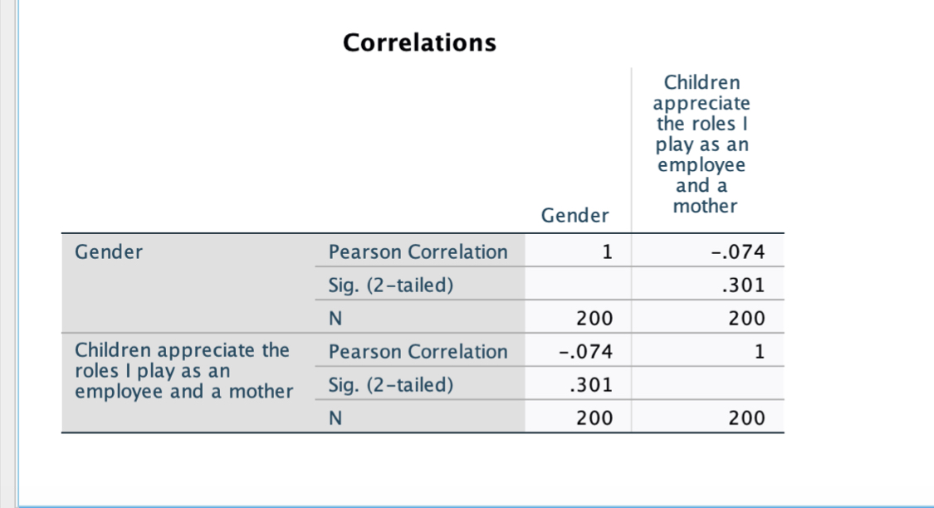
According to the study results in the table above, the gender aspect is negatively correlated at a value of -0.074to the children's perspective on the role that their mothers plays as employees and mothers. Since This indicates that children appreciate the role of women as mother and source of income at the family setting.
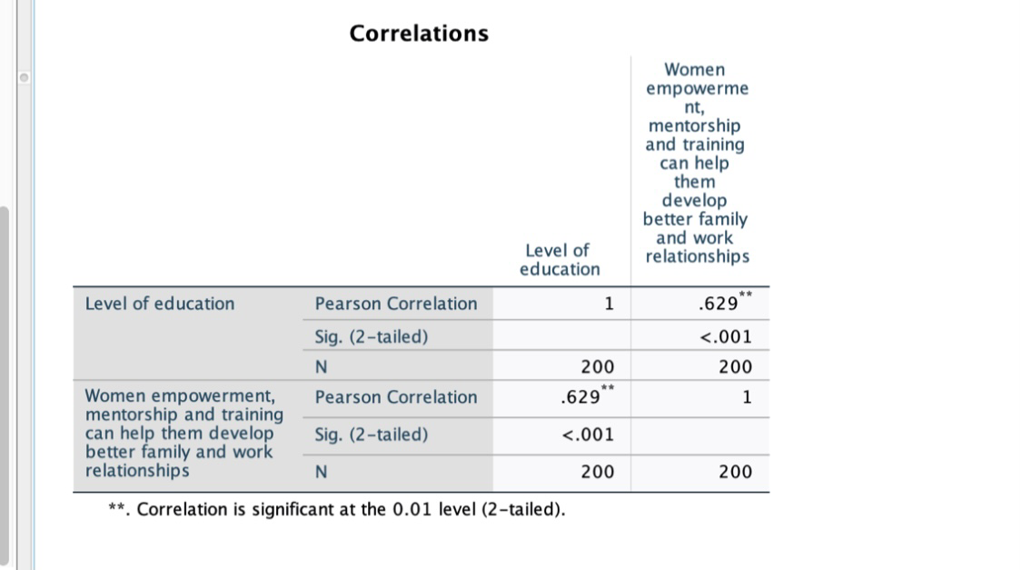

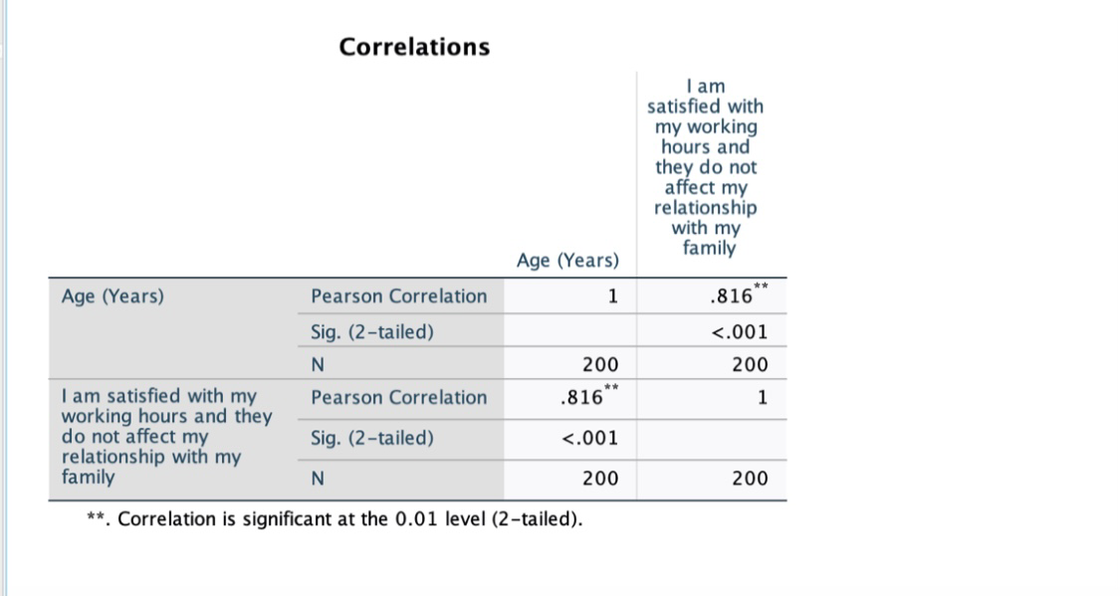
The table above shows that the level of education is positively correlated to women empowerment, mentorship, and training at a significance level of 0.629. That indicates that women's level of education affects their level of developing better families and work relationships.
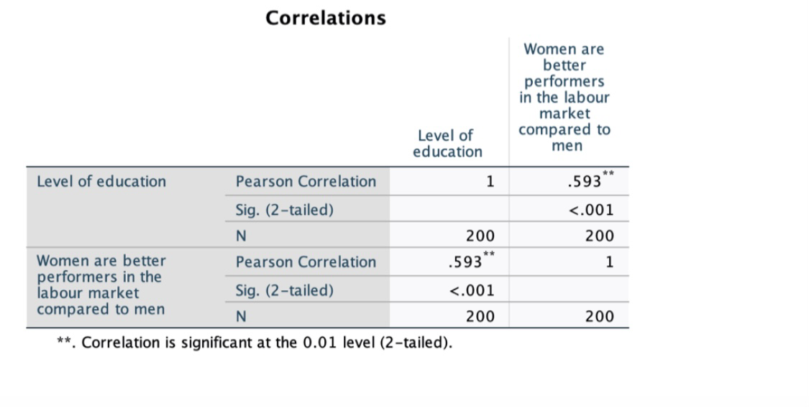
The data in the table above that age is positively correlated to the women's job working hours. It is an indication that age impacts the level of job satisfaction as well as job-work balance. According to the analysis, more than three-quarters of the women interviewed stated that relationships affect their working hours. On the other hand, women perform better in the labor market compared to their male counterparts.
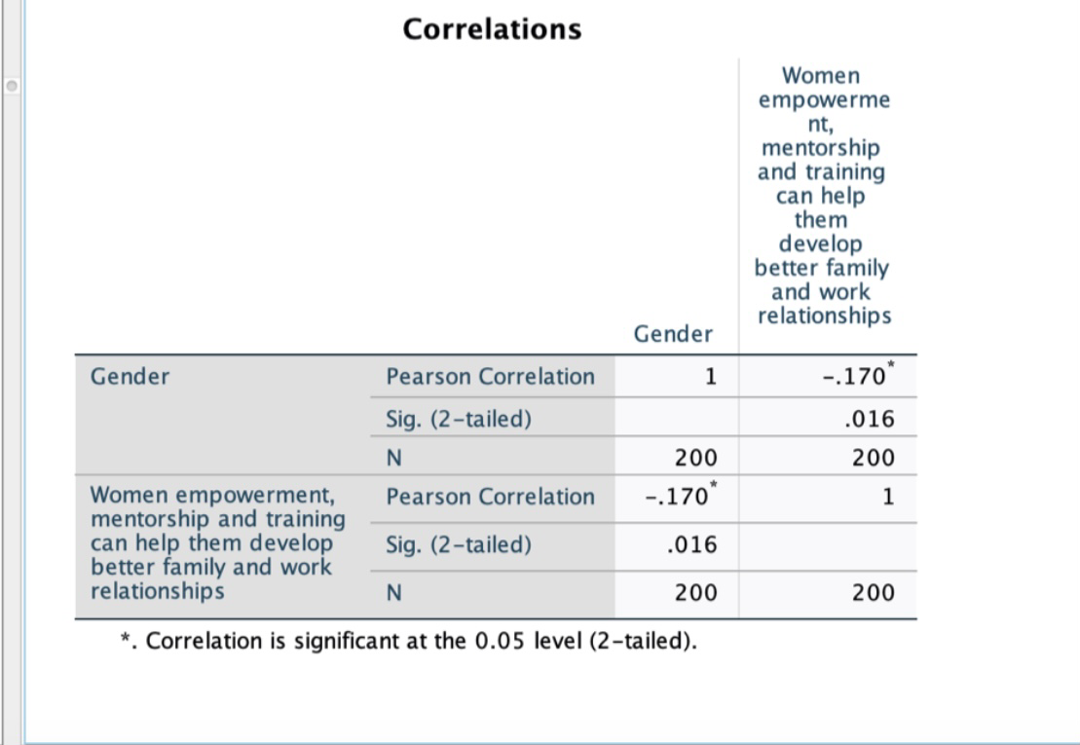

The findings in the figure above indicate the gender of the respondents is negatively correlated to women empowerment, mentorship, and training in helping them develop better family and work relationships. The2 tailed significance level was 0.16, which is more than the significance of 0.05. The analysis concluded that women are appreciated in the family. They are committed to both motherhood and work responsibilities. That means that women working in the UAE are dynamic and can handle their responsibilities efficiently. However, they must get training which will empower them in performing their duties.

Discussion and testing hypothesis
According to the study, the hypotheses (H1 and H2) are true. For example, Hypotheses of H1: there is the relationship between challenges and women working in the UAE. That was clear when the participants who were administered the questionnaires stated that women face multiple challenges while working in the UAE. Most of the women who filled in the questionnaire stated that they have a major problem trying to switch from family responsibilities to job responsibilities. Most women working in offices face numerous challenges because of their home responsibilities of taking care of their husbands and children. The study findings are in line with the literature observations made by several researchers. According to Al Jenaibi & Badreya (2015), work-life balance is one of the major challenges affecting employees worldwide. It is a challenge associated with the inability to coordinate between work roles and family life. Organizations that do not support their employees' work-life balance can incur direct and indirect costs due to reduced employee productivity, increased employee turnover, high-stress levels, and long overtime hours (Jabeen Badreya, 2015).
The second hypothesis H2: more challenges means more discrimination against women who need support. The study respondents stated that women's discrimination in the workplaces was more pronounced by the challenges they meet while working. That correlates with the study findings in the literature review. The change in women's perspectives in society is essential. Women play an important role in society, and they should be assisted in their areas of need. Women need policies that protect them in their workplaces since they play an important role in the UAE.
Effects of working hours on the relationship with the family were addressed in question 13. One hundred four women strongly disagreed that they were satisfied with the hours they spend at work. Fifty-six disagreed that they were satisfied with their work hours. Thirteen neither agreed nor disagreed with this claim. Seventeen agreed that they were satisfied with the hours they spent at work and did not affect their relationships with family. Ten strongly agreed that they were satisfied with the hours they spent working and had no negative effects on their family relationships. Findings gathered from these responses show that majority of working women had problems managing between work and family. Spending more time at work affected their relationships with their families.
Another challenge faced by working women is the lack of opportunities. This challenge was addressed in question 14. Ninety-nine participants strongly disagreed that there were adequate employment opportunities for women. Sixty-seven disagreed with this claim, while 4 participants remained neutral. Twenty-one participants agreed that women had adequate job opportunities. 9 responders strongly agreed that women have many employment opportunities. These responses show that women have limited opportunities to get employment compared with men.
The last question in the survey addressed the role of women empowerment, training, and mentorship. Ninety-six participants strongly agreed that women empowerment, training, and mentorship could help women develop better work and family relationships. Seventy-eight agreed that empowerment, training, and mentorship were necessary for women's success. Twenty agreed or disagreed with the claim. 2 participants disagreed that empowerment, training, and mentorship could improve work and family relationships for working women. 4 participants strongly disagreed with this claim. Findings in these responses indicate that empowerment, training, and mentorship play a critical role in working Emirati women.

PLAN TO IMPLEMENT STRATEGIES DEVELOPED TO ADDRESS CHALLENGES FACED BY WORKING EMIRATI WOMEN
The plan will focus on achieving a work-life balance, reducing the gender wage gap, empowering, mentoring, and training women, and enhancing effective and inclusive labor market policies. The strategic plan presented in the literature review analysis will be implemented using the following approach. The first step will be the communication of objectives. Executive leaders in the community will communicate goals that are consistent with the community's vision and values. By sharing these objectives with the affected population, they will be better positioned to align them with the concept. Weekly meetings will be necessary to communicate goals and review performances.
The second thing that needs to be done is driving accountability. Executives in organizations will need to lead by example, working towards achieving an equal work environment. All stakeholders will be held responsible for their tasks. Proper allocation of duties will establish competitiveness among employees and promote productivity. This step will require leaders to use the transformational leadership approach. Transformational leadership is an effective form of leadership that focuses on enhancing employee awareness of roles, understanding organizational and personal goals, and addressing employee needs (Bilgic & Badreya, 2015). Transformational leaders inspire and motivate employees, which, in turn, builds their confidence, trust, and self-esteem. Female workers can borrow positive attributes from these leaders and applying them in the workplace. Transformational leaders are considered role models and mentors.
Further, these leaders can transfer relevant knowledge and skills to employees, consistent with the organizational goals and values (Wong et al.). Being a role model is essential because it fosters innovativeness and creativity among women. When people interact with others who are more knowledgeable, the probability of developing competitive skills increases. When leaders pass positive behaviors to employees, they support the team's innovativeness, which, in turn, promotes progress and organizational success.
All stakeholders need to be action-oriented. This approach focuses on taking the appropriate actions to achieve goals. Female employees will optimally achieve their objectives depending on the ability of managers to train and motivate them. Integrating rigorous training programs will increase women's understanding of what is expected of them. Also, training programs increase competence and the ability to achieve organizational and personal goals.

LIMITATIONS OF RESEARCH
Limitations to this research include vulnerability to loss of information, biasness, and narrowing the study to selected sectors. These limitations affected the authenticity of the results.

CONCLUSION AND RECOMMENDATIONS
In a nutshell, although the women's positions have been elevated in the communities, there is a need to develop strategies that reduce the challenges that women face in workplaces. Women working in the Middle East face many troubles both in their families and at workplaces. Some of the challenges include limited leadership positions and the inability to have a work balance. Despite the challenges, women's participation in the labor force has improved, and in Emirates, more than 45% are in the active labor force. According to the UAE government's report, women's employment turnover accounted for 64% in 2015. However, due to men's dominance in workplace leadership, women are still vulnerable to discrimination and harassment issues. Additionally, women are excluded from law protection, and this exposes exploitation and the probability of harassment. Some of the factors promoting women's challenges include cultural restrictions, constitution failure, and lack of business training.
Organizations like the Centre of Arab Women for Training and Research (CAWTAR) have empowered women to be part of the labour force to address the challenges. As a result, the survey taken indicates that younger female recruits have been included in the labour force. From the results, increased educational attainment is linked to an increased number of employed women. However, only 1% of the total employed women rise to leadership positions. The report recommends that women be empowered by giving other women leadership positions in organizations. Additionally, the executive needs to lead by example and work towards ensuring equal opportunities in workplaces.

Works Cited
Al Jenaibi, Badreya. The Needs and Priorities of Women in UAE: Identifying Struggles and Enhancing Satisfaction of Employment, Education, Healthcare, and Rights. Contemporary Review of the Middle East. (2015), 2. 10.1177/2347798915601590.
Begum, Rothna. "Time to Take Action for Women in the United Arab Emirates."(2015). Available at https://www.hrw.org/news/2015/03/08/time-take-action-women-united-arab-emirates
Bilgic, R., Bulazer, M. B., Burumlu, E., Ozturk, I., & Tasciogiu, C. The effect of leadership on safety outcomes: The mediating roles of trust and safety climate. International Journal of Occupational Safety and Health, (2016), 6.1, 8-17.
Federal Authority for Government Human Resources. "Overview and analysis of employee turnover in the UAE federal entities (the subject of HR law) 2014". (, 2015). Available at https://www.fahr.gov.ae/Portal/Userfiles/Assets/Documents/42f53175.pdf
IFC and CAWTAR. Women Entrepreneurs in the Middle East and North Africa: Characteristics, Contributions, and Challenges. (, 2007).
Jabeen, Fauzia, Friesen Heather. L. and Ghoudi Kilani. Quality of work life of Emirati women and its influence on job satisfaction and turnover intention. Journal of Organizational Change Management. 31.2: 2018, 352-370.
Zangirolami-Raimundo, Juliana, Jorge de Oliveira Echeimberg, and Claudio Leone. "Research methodology topics: Cross-sectional studies." Journal of Human Growth and Development 28.3 (2018): 356-360.
MENA-FN. Over 40,000 Emirati women are employed in Abu Dhabi's public and private sectors. (2020). Available at https://menafn.com/1100705788/Over-40000-Emirati-women-employed-in-Abu-Dhabis-public-and-private-sectors
Muhtaseb, Yasmeen. Challenges facing women in the Middle East workforce. Available at https://www.arabianbusiness.com/content/376292-challenges-facing-women-in-the-middle-east-workforce
Ryan, Patrick. "Global Women's Forum Dubai: the gender pays equality in the Middle East still 150 years away." (2020). https://www.thenationalnews.com/uae/government/global-women-s-forum-dubai-gender-pay-equality-in-middle-east-still-150-years-away-1.980495
Salam, Abdul. Challenges Faced by Working Women in Al Ain City. International Journal of Humanities and Social Science. 2. 189-197. 10.20469/ijhss.2.20005-5
Sanhouri, M. Family, and obstacles were hindering Emirati women from engaging in work. (, 2014). Available at https://goo.gl/z3NEmF
The Atlantic. The Top Five Issues for Working Women Around the World. (, 2019). Available at https://www.theatlantic.com/sponsored/thomson-reuters-davos/the-top-five-issues-for-working-women-around-the-world/762/
Verma, Aarti, and Mulaniu Mahesh. Challenges and Issues of Working Women in the 21st Century. International Journal of Research in all Subjects in Multi Languages. 6.3: 2018, 2321-2853
Wesely, Marissa, and Dublon Dina. Empowering Women at the Grassroots. Stanford Social Innovation Review. Spring 2015. Available at https://ssir.org/articles/entryempowering-women-at-the=grassroot#
Frey, F. (2017). SPSS (Software). The International Encyclopedia of Communication Research Methods, 1-2.
Snyder, Hannah. "Literature review as a research methodology: An overview and guidelines." Journal of Business Research 104 (2019): 333-339.
Wong, J. H., Kelloway, E. K., and Makhan, W. Safety leadership. The Wiley Blackwell Handbook of the Psychology of Occupational Safety and Workplace Health, (2015), 83-110.
World Inequality Report 2018.

APPENDIX A
Survey Questions
To test the hypothesis and answer the research questions, thirty survey questions were formulated, fifteen based on demographics and fifteen based on the identified variables.
Demographic questions
- What is your gender?
- Male
- Female
- Prefer not to answer
- What is your age?
- 0 – 15 years
- 15 – 30 years
- 30 – 45 years
- 45 + years
- Please specify your ethnic background
- Emiratis
- Bedouin
- Expatriate
- Baloch
- Australian
- What is the location of your residence/ home?
- What is your level of education?
- High school
- Bachelor's degree
- Master's degree
- Ph.D. or higher
- Are you a working woman? / does your wife work?
- Yes
- No
- Are you married?
- Yes
- No
- What is your household income?
- Less than $25,000
- $25000 - $50000
- $50000 – $100000
- $100000 - $200000
- More than $200000
- What is your current employment status?
- Employed full-time
- Employed part-time
- Searching for an employment
- Retired
- How many years have you been employed? / how many years has your wife been employed?
- 1 – 2 years
- 2 – 3 years
- 3 – 4 years
- 4 – 5 years
- More than five years
- How many members of your family are dependent on you?
- None
- 1
- 2 – 4
- More than 4
- How would you describe your political view?
- Very liberal
- Liberal
- Very conservative
- Conservative
- Are you satisfied with your job?
- Yes
- No
- Are you career-oriented? / Is your wife career-oriented?
- Yes
- No
- Which languages are you capable of speaking fluently?
- Arabic
- English
- Spanish
- Portuguese
- Other
Likert scale questions
These questions will be answered based on a scale of 1 to 5; that is
- Strongly disagree;
- Disagree;
- Neither agree nor disagree
- Agree
- Strongly agree.

- Cultural values hinder the professional development of women
- Strongly disagree;
- Disagree;
- Neither agree nor disagree
- Agree
- Strongly agree.
- Another challenge faced by women is work-life balance
- Strongly disagree;
- Disagree;
- Neither agree nor disagree
- Agree
- Strongly agree.
- Women work for longer hours compared to men
- Strongly disagree;
- Disagree;
- Neither agree nor disagree
- Agree
- Strongly agree.
- The husband does not help in household roles
- Strongly disagree;
- Disagree;
- Neither agree nor disagree
- Agree
- Strongly agree.
- My husband helps me, so I do not get stressed and burned out
- Strongly disagree;
- Disagree;
- Neither agree nor disagree
- Agree
- Strongly agree.
- My husband believes that women should be given an opportunity in the labor market
- Strongly disagree;
- Disagree;
- Neither agree nor disagree
- Agree
- Strongly agree.
- My children appreciate the roles I play as an employee and a mother
- Strongly disagree;
- Disagree;
- Neither agree nor disagree
- Agree
- Strongly agree.
- There are non-competitive labor policies addressing women challenges
- Strongly disagree;
- Disagree;
- Neither agree nor disagree
- Agree
- Strongly agree.
- The percentage of women in the labor force has significantly increased in the 21st Century
- Strongly disagree;
- Disagree;
- Neither agree nor disagree
- Agree
- Strongly agree.
- Women are better performers in the labor market compared to men
- Strongly disagree;
- Disagree;
- Neither agree nor disagree
- Agree
- Strongly agree.
- The wage gap between men and women has remained the same over the years
- Strongly disagree;
- Disagree;
- Neither agree nor disagree
- Agree
- Strongly agree.
- There is a lack of suitable nurseries for children
- Strongly disagree;
- Disagree;
- Neither agree nor disagree
- Agree
- Strongly agree.
- I am satisfied with my working hours, and they do not affect my relationship with my family
- Strongly disagree;
- Disagree;
- Neither agree nor disagree
- Agree
- Strongly agree.
- There are numerous employment opportunities for women
- Strongly disagree;
- Disagree;
- Neither agree nor disagree
- Agree
- Strongly agree.
- Women empowerment, mentorship, and training can help them develop better family and work relationships
- Strongly disagree;
- Disagree;
- Neither agree nor disagree
- Agree
- Strongly agree.

APPENDIX B
Frequency Table of Age (Years)
Age (Years)
 |  | Frequency | Percent | Valid Percent | Cumulative Percent
Valid | 0 - 15 | 2 | 1.0 | 1.0 | 1.0
Valid | 16 - 30 | 87 | 43.5 | 43.5 | 44.5
Valid | 31 - 45 | 89 | 44.5 | 44.5 | 89.0
Valid | 46+ | 22 | 11.0 | 11.0 | 100.0
Valid | Total | 200 | 100.0 | 100.0

Frequency Table of Gender
Gender
 |  | Frequency | Percent | Valid Percent | Cumulative Percent
Valid | Male | 80 | 40.0 | 40.0 | 40.0
Valid | Female | 120 | 60.0 | 60.0 | 100.0
Valid | Total | 200 | 100.0 | 100.0

Frequency Table of Level of education
Level of education
 |  | Frequency | Percent | Valid Percent | Cumulative Percent
Valid | High School | 46 | 23.0 | 23.0 | 23.0
Valid | Bachelor’s degree | 146 | 73.0 | 73.0 | 96.0
Valid | Master’s degree | 7 | 3.5 | 3.5 | 99.5
Valid | Ph. D. | 1 | .5 | .5 | 100.0
Valid | Total | 200 | 100.0 | 100.0

Frequency Table of Household Income
Household Income
 |  | Frequency | Percent | Valid Percent | Cumulative Percent
Valid | Less than $25000 | 48 | 24.0 | 24.0 | 24.0
Valid | $25000 - $50000 | 100 | 50.0 | 50.0 | 74.0
Valid | $50000 - $100000 | 30 | 15.0 | 15.0 | 89.0
Valid | $100000 - $200000 | 20 | 10.0 | 10.0 | 99.0
Valid | Above $200000 | 2 | 1.0 | 1.0 | 100.0
Valid | Total | 200 | 100.0 | 100.0

Likert Scale Question I
Proffesional_Development
 |  | Frequency | Percent | Valid Percent | Cumulative Percent
Valid | Strongly Disagree | 2 | 1.0 | 1.0 | 1.0
Valid | Disagree | 10 | 5.0 | 5.0 | 6.0
Valid | Neither agree nor disagree | 20 | 10.0 | 10.0 | 16.0
Valid | Agree | 56 | 28.0 | 28.0 | 44.0
Valid | Strongly Agree | 112 | 56.0 | 56.0 | 100.0
Valid | Total | 200 | 100.0 | 100.0

Likert Scale Question II
Work_Life_Balance
 |  | Frequency | Percent | Valid Percent | Cumulative Percent
Valid | Neither agree nor disagree | 5 | 2.5 | 2.5 | 2.5
Valid | Agree | 65 | 32.5 | 32.5 | 35.0
Valid | Strongly Agree | 130 | 65.0 | 65.0 | 100.0
Valid | Total | 200 | 100.0 | 100.0

Likert Scale Question III
Longer_Hours
 |  | Frequency | Percent | Valid Percent | Cumulative Percent
Valid | Strongly Disagree | 20 | 10.0 | 10.0 | 10.0
Valid | Disagree | 14 | 7.0 | 7.0 | 17.0
Valid | Neither agree nor disagree | 28 | 14.0 | 14.0 | 31.0
Valid | Agree | 31 | 15.5 | 15.5 | 46.5
Valid | Strongly Agree | 107 | 53.5 | 53.5 | 100.0
Valid | Total | 200 | 100.0 | 100.0

Likert Scale Question IV
The husband does not help in household roles
 |  | Frequency | Percent | Valid Percent | Cumulative Percent
Valid | Strongly Disagree | 5 | 2.5 | 2.5 | 2.5
Valid | Disagree | 33 | 16.5 | 16.5 | 19.0
Valid | Neither agree nor disagree | 11 | 5.5 | 5.5 | 24.5
Valid | Agree | 57 | 28.5 | 28.5 | 53.0
Valid | Strongly Agree | 94 | 47.0 | 47.0 | 100.0
Valid | Total | 200 | 100.0 | 100.0

Likert Scale Question V
Husband helps me, so I do not get stressed and burned out
 |  | Frequency | Percent | Valid Percent | Cumulative Percent
Valid | Strongly Disagree | 78 | 39.0 | 39.0 | 39.0
Valid | Disagree | 69 | 34.5 | 34.5 | 73.5
Valid | Neither agree nor disagree | 12 | 6.0 | 6.0 | 79.5
Valid | Agree | 19 | 9.5 | 9.5 | 89.0
Valid | Strongly Agree | 22 | 11.0 | 11.0 | 100.0
Valid | Total | 200 | 100.0 | 100.0

Likert Scale Question VI
The husband believes that women should be given an opportunity in the labor market
 |  | Frequency | Percent | Valid Percent | Cumulative Percent
Valid | Strongly Disagree | 67 | 33.5 | 33.5 | 33.5
Valid | Disagree | 70 | 35.0 | 35.0 | 68.5
Valid | Neither agree nor disagree | 19 | 9.5 | 9.5 | 78.0
Valid | Agree | 31 | 15.5 | 15.5 | 93.5
Valid | Strongly Agree | 13 | 6.5 | 6.5 | 100.0
Valid | Total | 200 | 100.0 | 100.0

Likert Scale Question VII
Children appreciate the roles I play as an employee and a mother
 |  | Frequency | Percent | Valid Percent | Cumulative Percent
Valid | Strongly Disagree | 13 | 6.5 | 6.5 | 6.5
Valid | Disagree | 23 | 11.5 | 11.5 | 18.0
Valid | Neither agree nor disagree | 60 | 30.0 | 30.0 | 48.0
Valid | Agree | 55 | 27.5 | 27.5 | 75.5
Valid | Strongly Agree | 49 | 24.5 | 24.5 | 100.0
Valid | Total | 200 | 100.0 | 100.0

Likert Scale Question VIII
Non-competitive labor policies addressing women challenges
 |  | Frequency | Percent | Valid Percent | Cumulative Percent
Valid | Strongly Disagree | 4 | 2.0 | 2.0 | 2.0
Valid | Disagree | 10 | 5.0 | 5.0 | 7.0
Valid | Neither agree nor disagree | 11 | 5.5 | 5.5 | 12.5
Valid | Agree | 44 | 22.0 | 22.0 | 34.5
Valid | Strongly Agree | 131 | 65.5 | 65.5 | 100.0
Valid | Total | 200 | 100.0 | 100.0

Likert Scale Question IX
The percentage of women in the labor force has significantly increased in the 21st Century
 |  | Frequency | Percent | Valid Percent | Cumulative Percent
Valid | Strongly Disagree | 2 | 1.0 | 1.0 | 1.0
Valid | Disagree | 17 | 8.5 | 8.5 | 9.5
Valid | Neither agree nor disagree | 8 | 4.0 | 4.0 | 13.5
Valid | Agree | 71 | 35.5 | 35.5 | 49.0
Valid | Strongly Agree | 102 | 51.0 | 51.0 | 100.0
Valid | Total | 200 | 100.0 | 100.0

Likert Scale Question X
Women are better performers in the labor market compared to men
 |  | Frequency | Percent | Valid Percent | Cumulative Percent
Valid | Strongly Disagree | 45 | 22.5 | 22.5 | 22.5
Valid | Disagree | 50 | 25.0 | 25.0 | 47.5
Valid | Neither agree nor disagree | 23 | 11.5 | 11.5 | 59.0
Valid | Agree | 63 | 31.5 | 31.5 | 90.5
Valid | Strongly Agree | 19 | 9.5 | 9.5 | 100.0
Valid | Total | 200 | 100.0 | 100.0

Likert Scale Question XI
The wage gap between men and women has remained the same over the years
 |  | Frequency | Percent | Valid Percent | Cumulative Percent
Valid | Strongly Disagree | 19 | 9.5 | 9.5 | 9.5
Valid | Disagree | 41 | 20.5 | 20.5 | 30.0
Valid | Neither agree nor disagree | 20 | 10.0 | 10.0 | 40.0
Valid | Agree | 54 | 27.0 | 27.0 | 67.0
Valid | Strongly Agree | 66 | 33.0 | 33.0 | 100.0
Valid | Total | 200 | 100.0 | 100.0

Likert Scale Question XII
There is a lack of suitable nurseries for children
 |  | Frequency | Percent | Valid Percent | Cumulative Percent
Valid | Strongly Disagree | 8 | 4.0 | 4.0 | 4.0
Valid | Disagree | 12 | 6.0 | 6.0 | 10.0
Valid | Neither agree nor disagree | 12 | 6.0 | 6.0 | 16.0
Valid | Agree | 76 | 38.0 | 38.0 | 54.0
Valid | Strongly Agree | 92 | 46.0 | 46.0 | 100.0
Valid | Total | 200 | 100.0 | 100.0

Likert Scale Question XIII
I am satisfied with my working hours, and they do not affect my relationship with my family
 |  | Frequency | Percent | Valid Percent | Cumulative Percent
Valid | Strongly Disagree | 104 | 52.0 | 52.0 | 52.0
Valid | Disagree | 56 | 28.0 | 28.0 | 80.0
Valid | Neither agree nor disagree | 13 | 6.5 | 6.5 | 86.5
Valid | Agree | 17 | 8.5 | 8.5 | 95.0
Valid | Strongly Agree | 10 | 5.0 | 5.0 | 100.0
Valid | Total | 200 | 100.0 | 100.0

Likert Scale Question XIV
There are numerous employment opportunities for women
 |  | Frequency | Percent | Valid Percent | Cumulative Percent
Valid | Strongly Disagree | 99 | 49.5 | 49.5 | 49.5
Valid | Disagree | 67 | 33.5 | 33.5 | 83.0
Valid | Neither agree nor disagree | 4 | 2.0 | 2.0 | 85.0
Valid | Agree | 21 | 10.5 | 10.5 | 95.5
Valid | Strongly Agree | 9 | 4.5 | 4.5 | 100.0
Valid | Total | 200 | 100.0 | 100.0

Likert Scale Question V
Women empowerment, mentorship, and training can help them develop better family and work relationships
 |  | Frequency | Percent | Valid Percent | Cumulative Percent
Valid | Strongly Disagree | 4 | 2.0 | 2.0 | 2.0
Valid | Disagree | 2 | 1.0 | 1.0 | 3.0
Valid | Neither agree nor disagree | 20 | 10.0 | 10.0 | 13.0
Valid | Agree | 78 | 39.0 | 39.0 | 52.0
Valid | Strongly Agree | 96 | 48.0 | 48.0 | 100.0
Valid | Total | 200 | 100.0 | 100.0

